Room 100 Homework Packet
Due Friday, November 16th

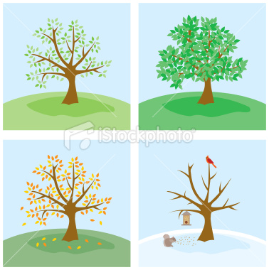

Caregiver signature:__________________________

Name:__________________________________________

Science/Literacy
Background: We’ve been talking about the change of weather around us in class.
Directions: Use the brown and green paper provided to help aide the creation of your own seasonal tree. You get to choose what it looks like.
Materials: (If you do not have a particular material at home, please, feel free to borrow some from school).
Glue
Scissors
Paper
Other craft material
Markers

Help your child create their own tree. Talk to them about how trees look different in different seasons. Take them on a walk outside as possible inspiration. Discuss with them what they see. Whether they choose to make a winter tree, fall tree, summer or spring tree, talk to them about what they’ve created. Allow them a chance to write down what they’ve made. Then I want an adult to dictate what they’ve said. Help guide them with possible prompts like:
“I made a…”
“This is a…”
“I like this tree because…”

Name:_______________________________
Science/Literacy continued
(using sight words)
As your child writes about their tree discuss some of the sight words they could use to explain their craft. Use these words simply as possible tools. The goal is to expose them to these words to make them more comfortable with individual words, not to drill them on the words. The more consistent exposure to these sight words, the faster they will become second nature to read.

- - - - - -

- - - - - -

- - - - - -

Name:__________________________________________

Parent activity sheet
Developing Phonological Awareness

Background: We make letters, letter sounds, and the sounds of words an integrated part of our school day. Every opportunity we have, we discuss the sounds that letters and words make. This can be done at home too.

Directions: Read the parent activity sheet and also consider doing something like this below:

In class we do different versions of the itsy bitsy spider that help build letter and word sound knowledge.

Instead of making the normal spider with your hands, make two sign language “I’s” and say “itsy bitsy” Stress the sound that “itsy” begins with---/i/ /i/ itsy

Then try the “big bad spider” while making the sign language letter for “B.” Stress the sound the “big” and “bad” begin with--- /b/ /b/ big

Draw and write about the songs that you sing. Let your child sound out words in the sound. Help them practice connecting the sounds their making to the letters they or you are writing
I B

Name:__________________________________________
Math
Background: Measurement and comparison is an important part of mathematical learning
Directions: Use the following activity examples from “Everyday Math” as a way to practice measurement concepts with your children. Remember, you do not have to limit yourself to what the activity says. Use items besides shoes and apples. Find materials that interest or engage your children. Make sure this is an opportunity for them to learn while enjoying themselves.

