Room 100 Homework Packet
Due Friday, January 18th
Community Workers
Look at what we’ve done already since we’ve come back!
- Fire fighter Gilbert came to talk about fire safety
- Custodians, Mr. Alex and Mr. John, showed us how they keep our school clean

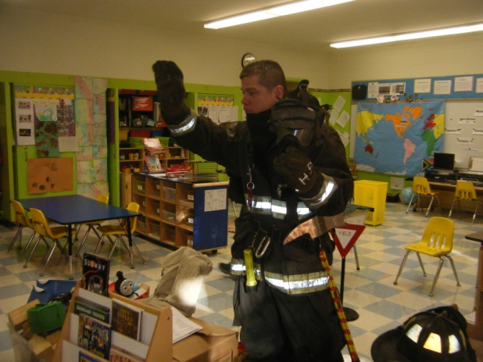

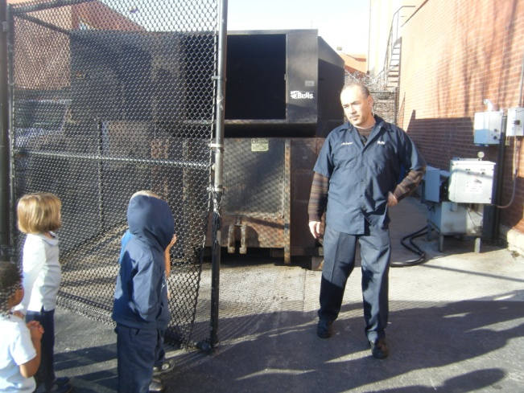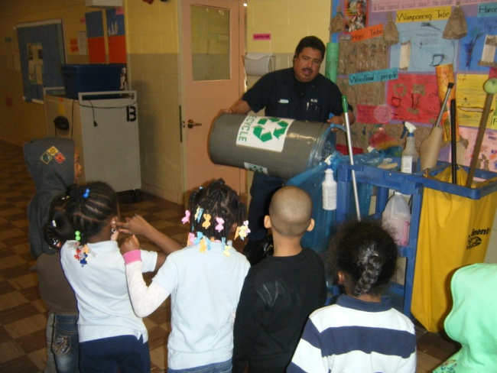

Still to come:
- Officer Godinez will talk about how police keep us safe
- Librarian Ms. White will show us how she maintains the library
- If you know a community worker: bus driver, train operator, postal worker…let me know so we can set up a time for them to come talk to the kids!

Caregiver signature:__________________________

Name:__________________________________________

Literacy
Make your room a Library
Background: In class we’ve talked about how a librarian takes care of books in the library and always makes sure they are in the right place so people can find them.
Directions: Gather all the children’s books you have at home for your child in order to put them in groups (all books that start with the letter ‘b’ for example.) Talk with your child about why they are putting them in to specific categories. This is an excellent opportunity for your child to, depending on their level, practice reading letters, words, and simple sentences.

Ask them questions that make them think about the letters they see and sounds they hear.
“How’d you know that was the title of that book?”
“Can you find a letter/word you recognize in the title?”

Families with children already working with sight words: We want to avoid drilling sight words in to preschoolers because that type of teaching tends to push kids further away from reading, rather than bring them closer. Additionally, drilling sight words is not connected to their past experiences or interests…an important part of a child’s learning. This is an opportunity to naturally encounter sight words in a reading setting.

Name:__________________________________________

Science
Garbage or Recycling?
Background: We’re learning about the difference between garbage and recycling from Mr. Alex and Mr. John. Talk to your child about how your family recycles.
Materials:
Plastic
Aluminum cans
Glass bottles
Paper

Tissues
Food
Food wrappers

Directions: Make sure you have a garbage and recycling bin at home. After meals and other waste creating times, talk to your child about whether something they have to throw away goes in the recycling or the garbage. Talk about why we recycle things at all.

Literacy extension: Tape a piece of paper on to your garbage and recycling bins at home. Have your child brainstorm different things that belong in either the garbage or recycling. As they think of something that belongs in the garbage, have them sound out the letters of that word and then write in on the paper for garbage. Do the same for objects that belong in the recycling.

Name:__________________________________________

Math
Stay LOW and GO
Background: Fire Fighter Gilbert taught us that in the event of a fire we should stay LOW…and GO. We’re incorporating this into our math activities at school and you can do the same at home! When we ask children where something is, we might often here “right there” or “over there.” We want to help build their mathematical language by incorporating more descriptive directions. “Next to”, “Beside”, “Beneath”, “Over”.
Directions: Make signs at home that read Next to, Beside, Beneath, Over, On, Behind, In front of, In. As fire fighter Gilbert taught us, we need to all make an escape plan in case of a fire. Make an escape plan with your child. Use these signs as a pathway to help build this vocabulary.

