Room 100 Homework Packet
Due Friday, January 25th

Room 100 is about to embark on a new journey with a project about
Recycling and Composting!

The students showed great interest in the act of recycling as well as the inner workings of a worm filled compost bin!

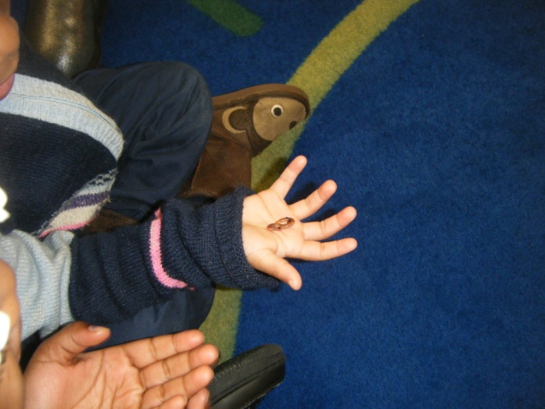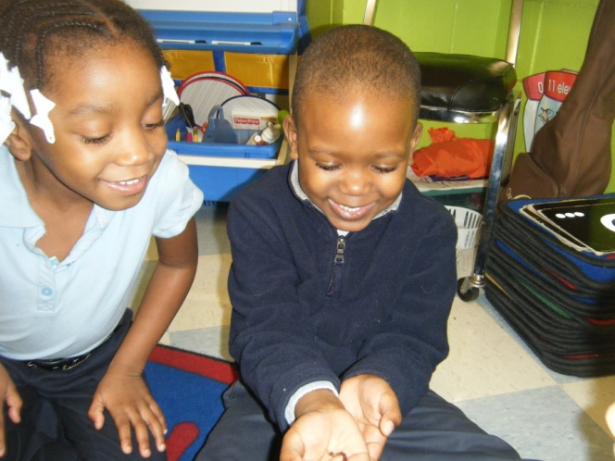

What will compost look like in our room?
Composting is like a form of recycling that you do yourself. In a plastic container we’ll have worms, fruit peels, newspaper, and other materials. The worms eat the food and then create “castings” (worm poop!) These castings are essentially dirt and can be reused as rich soil for gardening

Please feel free to come in to the classroom over the next few weeks to volunteer. I’m new at composting and I suppose many families will be too. We can all learn along with the students during this project about conservation

Caregiver signature:__________________________

Name:__________________________________________

Literacy
Separate Sounds Workout
Background: As children get better at hearing separate sounds in words, they become better at decoding words when trying to read and write. Practicing ways to separate sounds in words will help your child become a great reader and writer.
Directions: It’s cold outside, but we should still be getting exercise indoors! Have workout time with your family include learning about reading and writing!

Have your child decide on a topic of conversation. (Example below) Turn a sentence, word, or sounds into a workout.

This activity will look very different with children learning at different levels. 3, 4, and 5 year olds will be at very different levels from one another. Make sure you don’t push your child beyond what they’ll truly be able to do independently.

These are just examples. You should do a workout that your child will be interested in.

Do a jumping jack for each word you hear in a sentence (3 year olds):
Separate words in a sentence: /I/ /play/ /basketball/ /with/ /my/ /mom/

Do a push up for each syllable you hear in a word (3 and 4 year olds):
Separate syllables in a word: /bas/ /ket/ /ball/

Do a leg kick for the “onset and “rime” in a word (4 and 5 year olds):
“Onset” and “Rime” The first sound and then the remainder of the word: /m/ /om/

Do a sit up for each “phoneme” in a word (advanced 4 and 5 year olds):
“phonemes” Each individual sound in the word: /m/ /o/ /m/

Name:__________________________________________

Science
Living vs. Non-living
Background: Children are curious about their surroundings in the world. It’s important for children to begin to understand the differences between living and non living things, and how our lives are connected to the lives of other living things.

Directions: During family dinners this week talk to your child about the things on the table that are living and non living. How do they know what’s living or non living? Generally we think of something that can grow as living: people, plants, fruit, and animals vs. forks, plates, and cups.

Over the course of the week, have your child fill out this chart from things at the dinner table. Draw pictures and write words. PLEASE: let your child draw and let your child write. It’s the adult’s job to dictate after the child has completed their work

Living Non-living

Name:__________________________________________
Math
Go where the worm goes
(Do what we’re doing in school)
Background: We’re continuing our discussion of specific directions in class over the next two weeks. Here is some information from last week’s homework

When we ask children where something is, we might often here “right there” or “over there.” We want to help build their mathematical language by incorporating more descriptive directions. “Next to”, “Beside”, “Beneath”, “Over”, “Through”, “Around.”

Directions: Using the same idea as last week, you are going to adapt this activity for a compost bin. You and your child can pretend you’re worms in a compost bin. In a room with an especially large amount of toys, stuffed animals, etc. crawl around with your child pretending to compost the material into fertile dirt. Using the signs you were to make last week (words listed above) go through the room. Talk with your child about how you are getting from place to place. Encourage them to use more specific words than “right here” or “over there.”

Older students: Create a map of the room you’re going to crawl through. Draw the objects in your way and describe how you are going to get by them. Will you go around them? Through them? Under them? Use your map to guide you as you crawl with your family

