Room 100 Homework Packet
Due Friday, March 1st

Let’s get healthy!
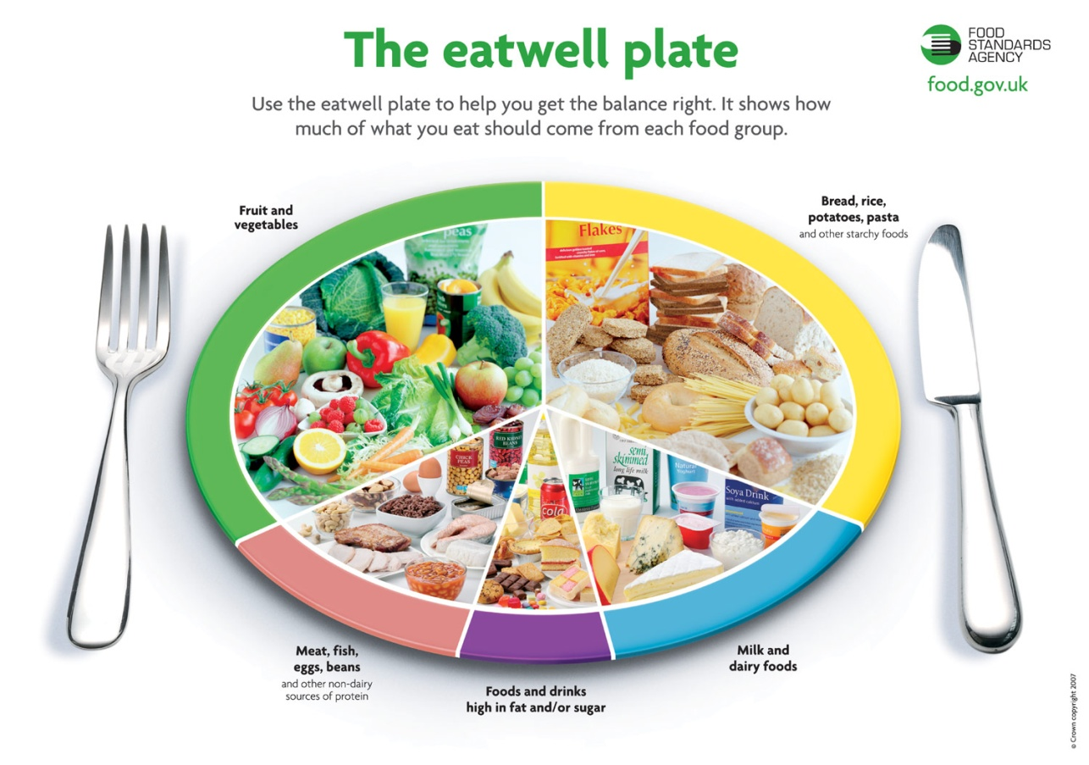

Half day Wednesday February 27th
- Regular day of school for A.M class
- No school for P.M class

Caregiver signature:________________________

Name:__________________________________________

My Plate
What to do: Talk to your child about the different food groups. Ask them to decide what their favorite type of food is in each group. Take 5 different blank pages and label the top of each a different food group. Allow your child to draw their choice of a favorite food in that food group.
If you are working on this homework with a 3 year old or 4 year old who may not talk much---give them choices. Don’t expect them to answer complex questions with no context. Use pictures or actual food to allow them to more easily answer your question. Ask them what they’ve drawn and write down exactly what they say. Make sure they watch you as you write so they can see the process.
If you are working on this homework with an older child let them experiment with the sounds they hear in the words. Please let them spell the word themselves first—no matter how different their writing is from the correct spelling. AFTER they’ve tried to sound out the word themselves praise them and write the word correctly next to what they’ve written.

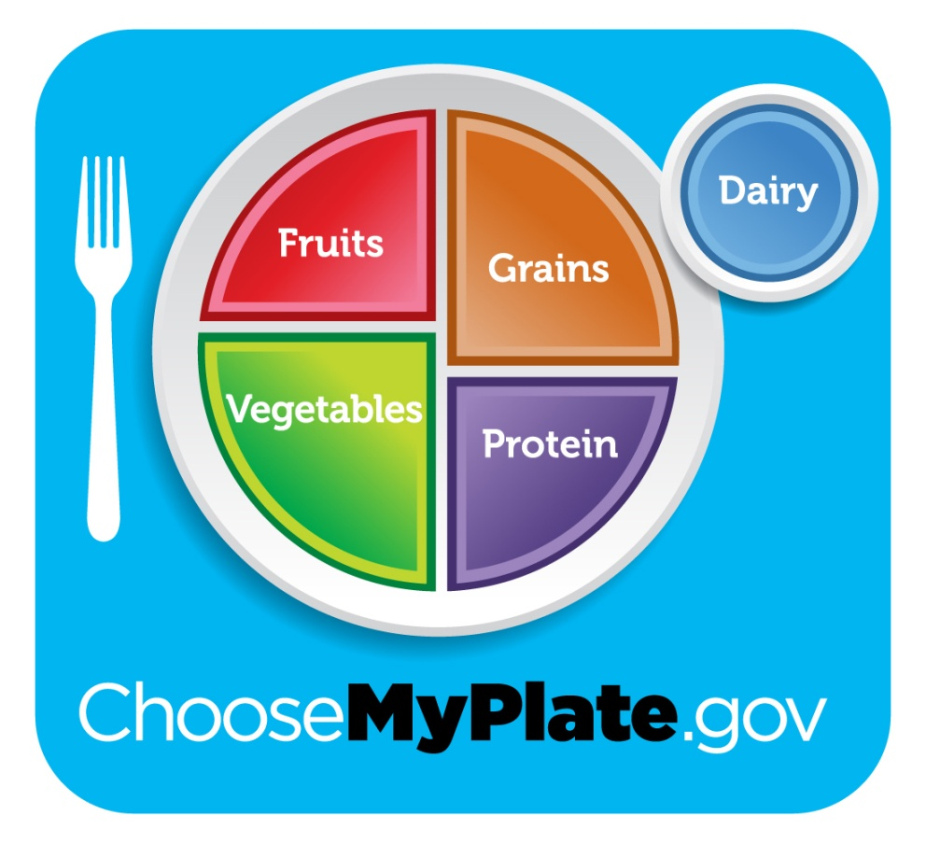

Name:__________________________________________
Letter Race
We have been playing the letter race game in class and the students love it. Here’s how to play at home

- Get at least one other friend to play this game.
- Write letters your child has difficulty with on printer paper.
- Tape the letters to the wall.
- Make duplicates of the letters to show to your child.
- Stand far away from the letters.
- (Adult): Hold up one of the duplicate letters and ask “what letter is this?”
- (Child): Call out the letter. Race to the correct letter on the other side of the room. If you do not call out the letter you can’t run to the letter. If you run to the wrong letter you do not get a point.
- The first one to the correct letter gets a point. The first one to 10 points wins!

Ways to modify this activity
Educational games like this can always be modified to meet the needs of your child. This game can be made to be easier or much harder.

- Make the game easier by only using a few of the letters in your child’s name. You don’t have to use the letters I suggested.

- Make the game a little harder by not holding up the duplicate cards. Example “Run to the letter that makes the /t/ sound.

- Make the game much harder by referring to words that start with that letter. Example “Run to the letter that is the first letter of the word ‘tiger.’”

- Make the game very hard by introducing sight words instead of letters. For example, use “the”, “in”, “this”, “to”, “go”, “is” Make duplicates of each of the words. Hold up one of the words. Just like the original activity, they must read the word before they run to it.

Keep track of your score here!-Play the game more than once-Just make a new score card

Name:__________________________________________

Math
Counting Seeds
Background: Integrating math activities into concepts that we’re learning about at school help children connect experiences and understand material more easily.

Directions: After eating different fruits for snacks this week, let your child take out the seeds for counting, adding, and subtraction. Use apples, oranges, lemons, etc. Use the boxes below to place the seeds.
Talk about the numbers they see.
Talk about how when we put two numbers together we get a larger number.
With subtraction, take away seeds, don’t place more on the paper like with addition
Make sure you have conversations with your child about what they’re doing
How did you do that? How is that the answer? How many more would you need to get this many?

1 | 2 | 3 | 4 | 5
6 | 7 | 8 | 9 | 10

+ =

Take away
? =

