Room 100 Homework Packet
Due Friday, March 15th

Let your kids do real things
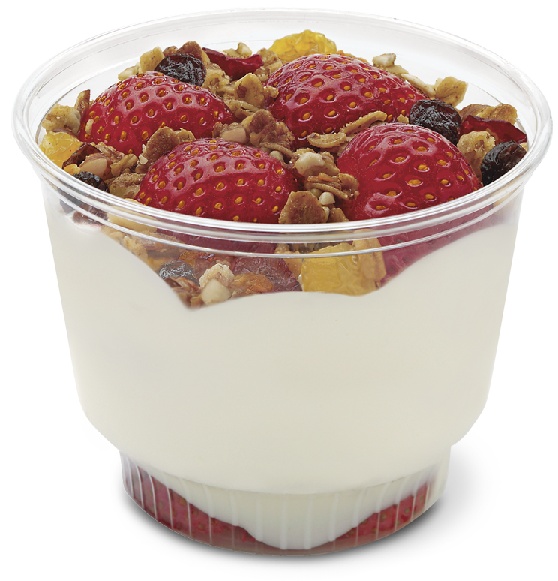

There’s not much that gets a young child interested more in learning than doing something real!
“Read this flash card” vs. “Let’s read this recipe to make something tasty!”

“Do this math problem” vs. “How much flour do you think we need for the pizza dough? Lets measure and talk about it.”

For the two weeks leading up to Spring Break, we’ll be putting a lot of focus on reading/making recipes and measuring. It would be great to have families involved in what we’re making this week. Come in to the classroom to participate.

Each day a few children will be sent home with sealed parfait cups for which they created a recipe and measured themselves. Look for them in back packs if you don’t personally pick up your child

Caregiver signature:________________________

Name:__________________________________________
Snack Time
Background information: Let your child decide what they want for a snack this week. When they have more control, they stay more engaged and interested.
What to do: Have your child decide the ingredients and the measurements necessary for their snack. Use recipes at home or online, not only as inspiration for your child, but as an opportunity to practice reading skills. Talk to them about the letters and words they see. As they measure out different amounts of what they’re making, help them document their recipe by writing it down.

PLEASE DON’T WRITE IT FOR THEM FIRST OR TELL THEM HOW TO SPELL SOMETHING FIRST. AS I TALK TO KINDERGARTEN AND FIRST GRADE TEACHERS, THE STUDENTS THAT ARE EXCELLING ARE THE STUDENTS THAT ARE WILLING TO TAKE RISKS WITH THEIR SPELLING AND MATH AND NOT RELY ON A TEACHER TO TELL THEM ALL THE ANSWERS. SHOW THEM HOW YOU WRITE THE SAME THING AFTER THEY’VE ALREADY HAD AN OPPORTUNITY TO WRITE. I SOUND LIKE A BROKEN RECORD BUT I’M STILL SEEING HOMEWORK WHERE THE PARENT DOES ALL OF THE WRITING FOR THE CHILD. AS WE DISCUSSED IN CONFERENCES, LETS HELP BUILD CONFIDENT KIDS

Make a recipe booklet. Use the outline given, but you can use blank copy paper from home too. I’ll laminate it at school if returned so it’s durable. You can use it as the menu in 20 years for their wedding

My Recipe for:____________________________

1.

2.

3.

4.

5.

Picture

My Recipe for:____________________________

1.

2.

3.

4.

5.

Picture

My Recipe for:____________________________

1.

2.

3.

4.

5.

Picture

