Room 100 Homework Packet
Due Friday, December 9th

Half day Wednesday, December 5th
(Normal day for A.M. No school for P.M)

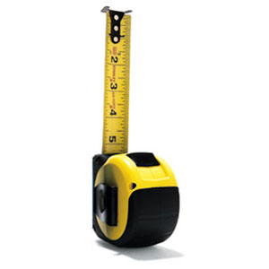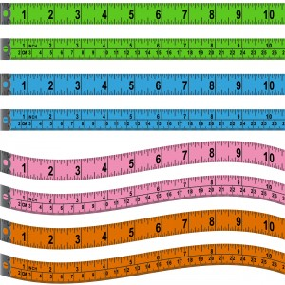
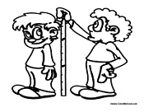

Attendance was worse in November than in October
A.M 89%
P.M 85%
PLEASE bring your child to school every day. If he or she must stay home because of illness, please let me know 847-704-2993. This attendance rate is unacceptable.
We want to be at 95% as a class

Caregiver signature:__________________________

Name:__________________________________________

Literacy
Background: Rhyming is an important skill that helps develop more independent readers.
Please note** Even if your child already seems to understand how to rhyme, rhyming activities can still be presented in a challenging way to encourage stronger reading development.
Directions: I’ve sent a similar activity home before, but I do not think it was completed by many families because of a possible lack of colorful paper. I’ve included different colored paper to aid the activity.
Talk with your child about what it means to rhyme. Give examples of rhyming sounds as well as sounds that do not rhyme. If at all possible, have your child select a word from a book you read together. Rhyme with that word. On color coated sheets of paper, have your child draw a picture of the word and then have them sound it out to write it. Let them be independent. After they have completed writing the word, then you model how you write it underneath. Have them make rhyming sounds and words and draw/write those on the same color paper. Start with a new set of rhyming words on a new color.
Make these available to your child every day. The color will help remind them which words rhyme with which. As they become stronger with rhyming, try using the same words and sounds but have your child close their eyes to determine rhyming so they do not have the help of the color coordinating.

Name:__________________________________________

Literacy
Background: In one of our books this week we saw a mouse tie-dying letters. We tried to do it ourselves in class and the students absolutely loved it.
Materials:
White cloth/old white t-shirt
Food coloring
Rubber bands
Permanent marker
Directions: Talk with your child about a letter they want to learn more about. If your child already knows the names and sounds of all the letters, ask them to choose a word that they’d like to practice. Practice writing the letter/word with permanent marker on the white cloth. Talk with them about the sounds they hear. Make sure they’re active while completing this project! After they’ve written their letter or word and then you’ve modeled how to write it after they have, roll the cloth and then wrap it twice in rubber bands. Then dip different parts of the cloth in water that has been slightly tinted with food coloring.

Name:__________________________________________

Math
Background: We will be doing a large amount of measuring during the next two weeks. You can do a lot of measuring at home to help build these math skills in your child.
Directions: Find a straight, sturdy object a home that is long (not a ruler). A shoe, pencil, marker, something like that will work. Go around your home measuring different objects. Find out how tall different objects are using your “ruler” as the standard unit of measurement (Mr. Cella is 7 shoes tall)
As you complete this activity, fill out the chart on the back side of this paper with your child. Let them take the lead, but make sure you are assisting them. Also, consistently ask questions to push their thinking.
Who is taller? How do you know that?
How much taller is this than that?
What was the shortest thing you found? How do you know that?

Math continued
Height

Object

Example

10
9
8
7
6
5
4
3
2
1
Height  Object | Table | Couch | Bed | Mr. Cella | T.V | Door

