Room 100 Homework Packet
Due Friday, February 8th

Composting and Worms!

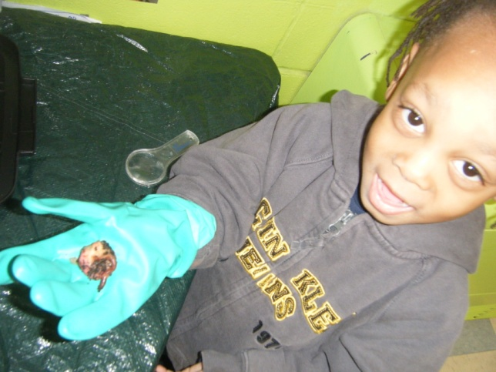

The students are becoming experts about worms. But we need your help at home. We’re doing these activities this week at school. Do them at home too to support what we’re doing in school. In addition, do some research with your child online and at the library!

Remember: We can all learn along with the students during this project. Come in to the classroom to help out

Caregiver signature:__________________________

Important message:
We will again be doing family conferences for the winter marking period. While K-8 grades will come out this week, our conferences will take place Feb 18-Feb22

Name:__________________________________________

Literacy
Story writing

Background: CHILDREN LEARN BY DOING. If we want our kids to be great writers and readers, let’s give them opportunities to do that.
Directions: We’re going to write our own stories about worms in class this week. At home, I want you to let your child write their own story about worms. Let them take control. It can be as realistic or silly as they wish. But the adult’s role is to facilitate their writing by having conversations about the plot, the characters, and the setting of the story. Ask your child questions about their story to encourage them to include as many details as possible.
Important:
- I only want to see children’s drawings. No adult drawing (unless your child wants to create a collaborative story. But don’t let them say “I don’t know how to draw that”)
- I want to see their writing (independent…I can tell if the adult sounded it out for them)
- I want to see that an adult dictated what the child intended to “write”

IF YOU BRING IN A STORY THAT YOUR CHILD WROTE, I WILL LAMINATE AND BIND THE PAGES FOR YOU

Name:__________________________________________

Science
Homemade play dough
Background: Children investigate and demonstrate their learning well through constructing.

Directions: Using the recipes below, try to make play dough at home. Using this play dough, encourage your child to demonstrate what they’ve learned about worms and compost bins. After they’ve completed it, bake it in the oven for a few minutes so it hardens!

Recipe 2
1 cup baking soda
1/2 cup corn starch
3/4 cup water
Have your child mix the baking soda and corn starch in a pot. Use hands to make sure all the lumps are broken up. Add water. The adult should put the pan on the stove over medium heat and stir constantly. As soon as the mixture gathers together, remove from the heat. When it cools, have your child knead it into a smooth dough. Don't over cook this dough or it will crumble.
Recipe 3
1/4 cup salt
1 cup flour
1/4 cup water
Have your child mix the flour and salt in a bowl then add water. Knead and squeeze the dough to make a clay consistency. You may need to add more water. Note: This dough doesn't last as long as the cooked recipe.
Ideas Divide into sections, then knead in food coloring (liquid or paste). Kids love making the white play dough change colors. Use unsweetened Kool-Aid for color and scent.

Name:__________________________________________
Social Studies
Research
Background: It’s safe to say that your kids know their way around a computer a four years old more than I did when I was fifteen! Use the internet as a research tool with your child

Directions: Ask your child the questions they may have about a worm?
Where is its head?
Where is its tail?
Do they have teeth?
Write down some of these questions that you and your child have and then get onto your computer or smart phone! With your child next to you, go to Google and type in the question your child has. Read about the answers and look at the pictures together. Let your child write and draw about your investigations below

Questions Answers

